Customer Review Analytics through Sentiment Insights

P S Metkewar and Ravi Chauhan

Symbiosis Institute of Computer Studies and Research (SICSR),

Symbiosis International (Deemed University) (SIU),

Model Colony, Pune, Maharashtra, India

[pravin.metkewar@gmail.com](mailto:pravin.metkewar@gmail.com), [raviadmn143@gmail.com](mailto:raviadmn143@gmail.com)

***Abstract -* Today, customer reviews are one of the most important areas for the businesses to grow, by analysing their sentiments and understanding them. This research paper focuses on how customer reviews and feedbacks are helpful for businesses to grow. Authors say that the proposed methodology focuses on the collection of the data from different sources and then applying pre-processing techniques, Exploratory data analysis (EDA), Natural Language Processing, sentiment analysis and fine-grained aspect-based analysis on that. Furthermore, this will help the businesses to get the proper insight from the customer dataset and as well as help businesses to focus more on the problem of customers stated by them in the reviews.**

**Although, this topic is already well studied but authors have chosen this topic to get the fine-grained aspect-based analysis of the customer reviews, as authors saw the research gap here, that the earlier studies focus solely on the customer reviews as a whole but not on the fine-grained aspect-based analysis. So, the authors will focus more on fine-grained aspects to bridge the research gap by incorporating machine learning and deep learning algorithms to associate sentiment scores with each aspect, hence, it will help to get the good and accurate insights from the reviews.**

**Keywords: Customer review analytics, sentiment analysis, fine-grained analysis, sarcasm detection, temporal analysis, biased reviews, manipulated reviews, NLTK, K-Means Clustering.**

##### Introduction

In this fast-moving world today, businesses need to understand their customers well to get the front seat in the today’s market. Authors observed that these customer reviews help businesses to get the better insights from the reviews or feedbacks of customers and can understand the sentiments too. However, earlier researchers and analysts used to focus primarily on the sentiments of customers as a whole so, this was not enough to catch the deep emotions of the customers. Moreover, authors want to say that to focus on these deep emotions we need to focus more on fine-grained aspect-based analysis of the customer reviews.

The aim of this research paper is to fulfil the gap where the focus was solely on the customer sentiments as whole but not on the fine-grained aspects. So, authors say that they will provide a fine-grained aspect-based sentiment analysis in this research paper which will help businesses or organizations to focus more deeply and accurately on the customer reviews or feedbacks. They will use machine learning and natural language processing, and the fine-grained aspect-based analysis using the sentiment classification at the aspect level, managing the context in which aspects are mentioned and handling the variability of aspect expressions.

Further, authors say that they will use the customer data of hotels which will provide the hotels to focus more on the feedbacks and the reviews of the customers. Moreover, it will also help hotels to focus on the strengths and weaknesses in the service provided by them after analysing the reviews and customer feedbacks. They will look up to minimise the areas of common problems and improve them, as a result it will help in better customer satisfaction in the future and increase the value of the hotel.

Authors state that this research paper will not neglect the fine-grained aspect-based sentiment analysis which used to get neglected earlier and in today’s fast-moving world it is not enough to focus on the whole sentiment but you need to focus deeply on the sentiments and get the correct insight what customers actually want to say. Ultimately, this will help businesses or hotels to grow as they can focus more accurately on the actual need and feedback of their customers.

##### Literature Review / Related Work

Customers review analytics has gained a hype in the recent years and this is worth it for the businesses to grow in the long-run and get themselves more opportunities to provide better services to their customers hence, they get happy and more satisfied from the businesses. Authors state that this “customers review analytics” is a very vast topic and the studies on this topic are also been conducted from a long time, but these studies lack in the analysis of customers from the fine-grained aspect-based point of view. Earlier, the studies majorly focus on customers review as a whole emotion or sentiment, which classifies the reviews into three categories that is positive, neutral and negative reviews. Authors further added that they have used [1] Natural Language processing to analyse the reviews of the customers and draw the insights with the help of [2] business intelligence from the [3],[11],[17] big data of customers reviews.

Furthermore, the authors have added that this research have witnessed the very deep research efforts. They further added that the [6],[25] machine learning classification and clustering techniques have been used in this research with a combination of deep learning algorithms and natural language processing, which helped in knowing the deeper [7] sentiments of customers. To be more precise this research basically focused closely on the fine-grained aspect-based [4], [5] customers review analytics which was possible by analysing word-metrices and aspect-based analysis.

Authors also elaborate that to address this research gap the studies have already been done by exploring the [8] topic modelling, rule-based analysis and dependency parsing which helped to get the fine-grained analysis. Although these studies also tried to focus on fine-grained analysis but the problem is still the same which is they were not able to focus accurately on the selection of aspects or [28] domain specific analysis or [9], [12] sentiment associated with [10] specific aspects of product or service.

The authors further added that for the fine-grained analysis, the aspect-based analysis is very important. For this purpose, many machine learning algorithms like Support Vector Machines (SVM), Naïve Bayes, [13],[16],[19],[20],[22] K-Means Clustering and the deep learning algorithms like [21],[23],26],[32] Recurrent Neural Networks (RNN) and Convolutional Neural Networks (CNN) can be used to get the fine-grained aspect-based analysis, with the help of natural language processing. Further, these models and algorithms focuses on the word-dependencies metrics and can help in finding the [14],[15],[18],[27],[29] aspect-based sentiments analysis more accurately.

During this study authors observed that there is a problem in [35],[36],[37],[40] fine-grained analysis which is customers can use same words or phrases for the different issues and the opposite is also possible which is customers can use different words or phrases to point out same issue or problem. However, this problem was tackled by using the techniques like word embedding, stemming and aspect clustering which helped in [24] accurate sentiment analysis. Further, authors have enlightened that it is very much crucial in aspect-based sentiment analysis in which aspect or context the review is talking. Authors also suggest that to get the [30],[31] high accuracy in sentimental analysis of different aspects, it is very much needed to consider the position of aspect in the review, co-occurrence of aspect and the linguistic cues, which helps in accurately [45] classifying the sentiments. Moreover, there are more challenge like [34] aspect ambiguity, handling noisy or unstructured customer reviews and cross-domain aspect-based sentiment analysis.

Finally, authors say that this research paper focuses more specifically on the [41] fine-grained aspect-based sentiment analysis of the customer reviews. Although, there were challenges which were tackled by the authors in analysing the customers reviews stated above. Earlier, the researches focused on the sentiment analysis as a whole emotion which is positive, negative or neutral review but this research paper fills this research gap by analysing [33],[38],[39] reliable fine-grained aspect-based sentiment analysis. Finally, it helped hospitality industry to focus more accurately on the customers reviews and what they want to say through the reviews, ultimately through this, industries can grow in the market and can have a better impact on the society and this also helps in [42],[43],[44] customer satisfaction.

##### Methodology

## *Dataset*

Authors have obtained the U. S Hotel Customer Data, which contains data with column names as address, categories, city, country, latitude, longitude, name, postalcode, province, reviews.date, reviews. dateAdded, reviews.doRecommend, reviews.id, reviews.rating, reviews_text, reviews.title, reviews.userCity, titles.username, reviews.userProvince. Authors have used Python and various data visualization tools such as Matplotlib and Seaborn to analyse and visualize the dataset.

## *Data Preprocessing and Representation*

There are 35912 rows and 19 columns in our dataset. Although we have some empty data in the dataset but it does not affect our results, so, we don’t do anything with that empty data. But we drop 2 columns reviews.doRecommend and reviews.id because there is no data available in both of them. As we are doing the customer reviews analytics, so there is some visualization done using python to better understand the data.

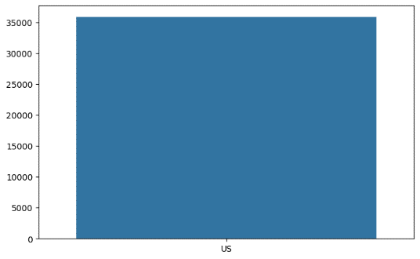

Fig.1. Country Wise Reviews Count.

The data visualized in Fig.1. highlights the country wise count of reviews. We can clearly see there is only one country i.e., US, and the reviews count value is more than 35000.

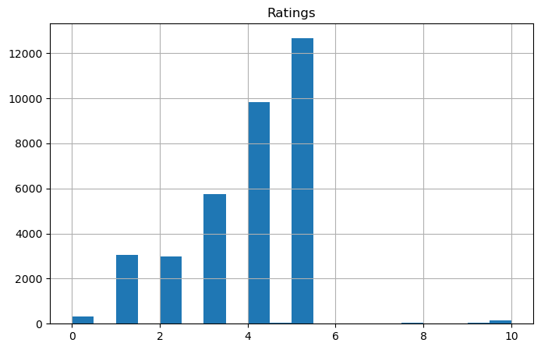

Fig.2. Ratings Of Reviews.

As visualized in Fig.2. we can see that majorly ratings received was 5 and it shows that the customers are actually happy.

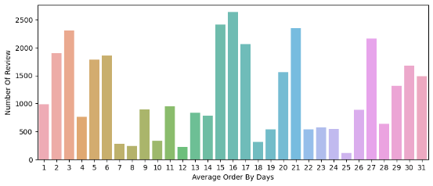

Fig.3. Number Of Reviews Accordig To Average Order By Days.

From Fig.3. we can observe the Average order by days of month corresponding to the number of reviews.

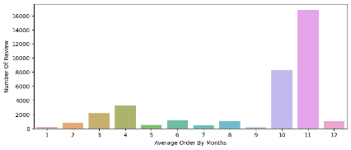

Fig.4. Number Of Reviews Accordig to Average Order by Months.

From Fig.4. we can observe the Average order by months corresponding to the number of reviews and hence, authors say that in the month of November the orders were the most.

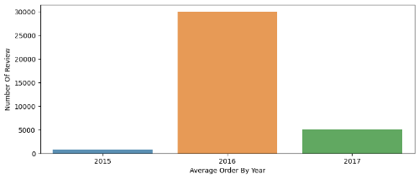

Fig.5. Number Of Reviews Accordig to Average Order by Year.

From Fig.5. we can observe the Average order by year corresponding to the number of reviews.

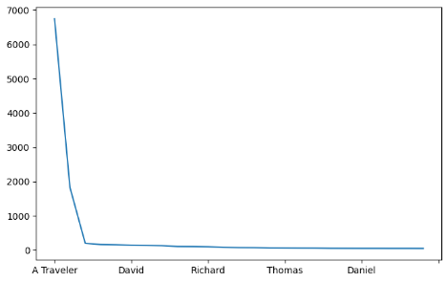

Fig.6. Frequent Name.

The data visualized in Fig.6. shows the most frequent user name who gave the review and hence, this also focuses on the major and frequent clients and the hotels should give standout benefits and offers to these frequent clients.

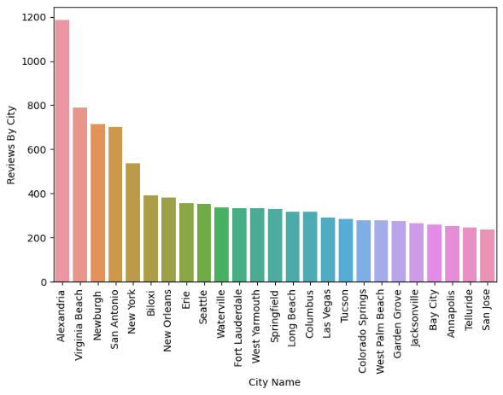

Fig.7. City Wise Reviews Count.

From Fig.7. we can observe the city-wise reviews count. It shows the number of reviews according to the different cities.

## *Feature Selection*

In our dataset, reviews are the most important feature and shows the direct emotions and unfiltered feedback of the customers so, we will do the further computation on that feature majorly.

## *Mathematical Model*

*K-Means Algorithms:*

The K-means algorithm clusters data by separating samples in k groups, minimizing a criterion known as the inertia or within-cluster variance sum-of-squares.

arg s min ∑i=1 k ∑x ∈ si ||x – μi||2

Where:

S sets of observations

k number of sets of predictors

x observation data point

μi mean of points in Si

Feature Selection:

**N(d,f,p)**

**M(d,f,p,m)**

**A(d,f,p,m)**

{f1, f2, ….,fs }

{d1, d2, ….,dn}

{f1, f2, ….,fa }

F

where:

d data

n number of data elements

f features

a number of available features

p prediction objectives

m models

s number of selected features

F feature selection functions

N mining functions

M modelling functions

A analysis functions

## *Word Embedding*

Word Embedding is one of the major concepts which comes under Natural Language Processing (NLP). It also represents words as dense vectors in a continuous vector space. Moreover, it also helps words or phrases to convert into numerical data on which further machine learning algorithms can be applied. Word embedding also maps words to continuous vector spaces, where similar words have similar vector representation. Moreover, in Fig.8. the word embedding process has been shown and authors say that word vector or word embedding is an approach of representing words. Moreover, it is a technique to convert the words or phrases into numerical values which helps machine learning models to work on them.

Words Collection

Retrieval

Algorithm

Word Vectors

Training

Algorithm

Word Vector

**Fig.8. Word Embedding Process.**

##### Results And Discussion

## *Clusters*

TABLE.1. NUMBER OF REVIEWS INCLUDED IN EACH CLUSTER.

|  |  |
| --- | --- |
| Clusters | No of Reviews |
| 4 | 372 |
| 1 | 246 |
| 2 | 189 |
| 3 | 138 |
| 0 | 55 |

Table.1. shows the number of reviews belongs to each cluster. Furthermore, it is observed that there are 5 clusters from 0 to 4 and corresponding to the clusters we have number of reviews assigned to each cluster. Authors have developed this table using python.

TABLE.2. SAMPLE OF REVIEWS ACCORDING TO CLUSTERS.

|  |  |  |
| --- | --- | --- |
|  | Review | Cluster |
| 0 | Pleasant 10 min walk along the sea front to... | 3 |
| 1 | Really lovely hotel. Stayed on the very…. | 2 |
| 2 | Ett mycket bra hotell. Det som drog ner… | 4 |
| 3 | We stayed here for four nights in October… | 2 |
| 4 | We stayed here for four nights in October… | 2 |
| 5 | We loved staying on the island of Lido! | 4 |
| 6 | Lovely view out onto the lagoon. Excellent.. | 4 |
| 7 | Ottimo soggiorno e ottima sistemazione nei.. | 4 |
| 8 | Gnstiger Ausgangspunkt fr Venedig Besuche. | 0 |
| 9 | Lidoen er perfekt til et par dages ro…… | 4 |

From the above table.2. authors focus on the reviews or feedbacks given by the customers. The above table focuses on the reviews written in a particular language and the corresponding clusters assigned to each review, although, it is just a sample of ten reviews.

## *Aspect-Centric Sentiment Analysis Results:*

Authors say that the main part of this research is based on the fine-grained aspect-based sentiment analysis rather than on the traditional method of analysing reviews as a whole, or classifying them into positive, negative and neutral sentiments. Moreover, authors add that this particularly focuses on the particular aspect, represented by the topic words and analysing sentiment trends related to these aspects. Authors also add that with this methodology they gained deeper insight of the customer reviews which was not possible to understand earlier and through this it will be very easy for the hotels or businesses to focus more on the actual problem rather than focusing on a collective problem, because in this growing competition this fine-grained aspect-based analysis is very much needed.

## *Topic Word Matrices*

|  |  |  |  |  |  |  |  |  |
| --- | --- | --- | --- | --- | --- | --- | --- | --- |
|  | Word 0 | Word 1 | Word 2 | Word 3 | Word……. | Word 12 | Word 13 | Word 14 |
| Topic 0 | great | de | stay | le | complaint | spa | lido | view |
| Topic 1 | hotel | excel | pool | stay | area | littl | also | friend |
| Topic 2 | clean | roo, | good | breakfast | pool | night | visitor | price |
| Topic 3 | room | hotel | stay | breakfast | need | one | time | could |
| Topic 4 | und | sehr | das | der | fr | zimmer | zu | es |

TABLE.3. WORD MATRICES.

From table.3. it can be inferred that the columns focus on the words and the rows focuses on the topics and this topic-word metrics shows the strength of each word to the topic. Authors say that this is very crucial of the sentiment analysis as it helps to identify which words are strongly linked to which aspect.

Authors say that with the help of topic modelling techniques authors have analysed topic word matrices which formulated them with the deeper and specific aspect-based analysis on the hotel reviews. Moreover, authors also add that these matrices helped them to get the holistic sentiment views parallel to the particular aspect, which ultimately helped them in extracting the multi-faceted nature of the customer opinions.

## *Aspect-Level Sentiment Dynamics*

Authors observed sentiment dynamics in various different aspects. For example, authors say that the “staff was very welcoming”, which is a positive thing authors observed during the analysis of the customer reviews. Further, authors add that the customers added that “some amenities or devices in the rooms were not working properly”, which is not good for the customers as they are paying for the stay and want good conditions of all the devices in-return. Moreover, authors observed that there were sentiment fluctuations in case of some customers as some stated “food quality” as good and some just gave negative reviews for that. So, such deep and meaningful insights give hotels an idea or the area in which they should improve by working on them.

##### Challenges and Future Prospects

Authors tackled many challenges while approaching this study of customer reviews. For instance, authors faced challenge while fetching the accurate aspect from the reviews. Moreover, authors also faced challenge in interpreting the contextual understandings which include sarcasm, irony and cultural nuances. One more major problem faced by the authors was while analysing multilingual and cross-domain analysis.

Additionally, authors say that there are very broad areas in which future studies can be done. Like in extracting the accurate aspect the models of natural language can be combined with the deep-learning and future research can also focus on analysing multi-languages and also the contextual sentiments which can throw the umbrella of layers.

##### Conclusion

In conclusion, this research paper majorly focuses on the fine-grained aspect-based sentiment analysis with the help of the topic word metrices. Therefore, authors say that this will help the hospitality industry to create accurate strategies to give the best possible services to their customers. This approach helped to bridge the research gap in sentiments analysis for hotel reviews as it is not focusing on the traditional analysis of sentiments as a whole that is positive, negative and neutral. Authors also promise that this study not only provide benefits to the hospitality industry but also can be used to analyse customer sentiments in diverse domains.

##### Conflict of Interest

The authors declare no conflict of interest regarding the publication of this research paper.

##### Author Contributions

Author Ravi Chauhan did data collection, literature review, experimentation, result and discussion. Author Dr P S Metkewar did the Investigation, verification, validation and conclusion.

##### Acknowledgment

The authors wish to thank Symbiosis Institute of Computer Studies and Research for providing the infrastructure and resources needed for making this research.

##### References

[1] A. B. Maqsood, A. Maag, I. Seher and M. Sayfullah, "Customer data extraction techniques based on natural language processing for e-commerce business analytics," 2021 6th International Conference on Innovative Technology in Intelligent System and Industrial Applications (CITISIA), Sydney, Australia, 2021, pp. 1-8, doi: 10.1109/CITISIA53721.2021.9719914.

[2] *S. Atul Khedkar and S. K. Shinde, "Customer Review Analytics for Business Intelligence," 2018 IEEE International Conference on Computational Intelligence and Computing Research (ICCIC), Madurai, India, 2018, pp. 1-5, doi: 10.1109/ICCIC.2018.8782305.*

[3] *W. K. R. Perera, K. A. Dilini and T. Kulawansa, "A Review of Big Data Analytics for Customer Relationship Management," 2018 3rd International Conference on Information Technology Research (ICITR), Moratuwa, Sri Lanka, 2018, pp. 1-6, doi: 10.1109/ICITR.2018.8736131.*

[4] *T. Le, V. -H. Nguyen and T. Ho, "A Model of Discovering Customer Insights in Tourism Sector Approach to Vietnamese Reviews Analytics," 2022 9th NAFOSTED Conference on Information and Computer Science (NICS), Ho Chi Minh City, Vietnam, 2022, pp. 205-210, doi: 10.1109/NICS56915.2022.10013410*

[5] D. Suryadi, "Predicting Repurchase Intention Using Textual Features of Online Customer Reviews," 2020 International Conference on Data Analytics for Business and Industry: Way Towards a Sustainable Economy (ICDABI), Sakheer, Bahrain, 2020, pp. 1-6, doi: 10.1109/ICDABI51230.2020.9325646.

[6] G. Lampropoulos, K. Siakas, J. Viana and O. Reinhold, "Artificial Intelligence, Blockchain, Big Data Analytics, Machine Learning and Data Mining in Traditional CRM and Social CRM: A Critical Review," 2022 IEEE/WIC/ACM International Joint Conference on Web Intelligence and Intelligent Agent Technology (WI-IAT), Niagara Falls, ON, Canada, 2022, pp. 504-510, doi: 10.1109/WI-IAT55865.2022.00080.

[7] M. Ngaboyamahina and S. Yi, "The Impact of Sentiment Analysis on Social Media to Assess Customer Satisfaction: Case of Rwanda," 2019 IEEE 4th International Conference on Big Data Analytics (ICBDA), Suzhou, China, 2019, pp. 356-359, doi: 10.1109/ICBDA.2019.8713212.

[8] Q. Ma, H. Du and Z. Wang, "A Novel Perspective to Mining Online Hotel Reviews Based on Biterm Topic Model," 2021 IEEE 6th International Conference on Big Data Analytics (ICBDA), Xiamen, China, 2021, pp. 310-315, doi: 10.1109/ICBDA51983.2021.9403060.

[9] G. Andreev, D. Saxena and J. K. Verma, "Impact of Review Sentiment and Magnitude on Customers' Recommendations for Video Games," 2021 International Conference on Computational Performance Evaluation (ComPE), Shillong, India, 2021, pp. 992-995, doi: 10.1109/ComPE53109.2021.9752380.

[10] I. I. Ibrahim, "Social Media Analysis in Building Customer Trust - Systematic Literature Review," 2022 International Conference on Information Management and Technology (ICIMTech), Semarang, Indonesia, 2022, pp. 39-44, doi: 10.1109/ICIMTech55957.2022.9915099.

[11] A. Kapoor and V. Attri, "A Review of Tools and Technologies for Big Data Analytics," 2021 10th International Conference on System Modeling & Advancement in Research Trends (SMART), MORADABAD, India, 2021, pp. 13-16, doi: 10.1109/SMART52563.2021.9676237.

[12] I. C. Juanatas, R. R. Fajardo, E. T. Manansala, A. A. Pasilan, J. R. Tabor and H. D. A. Balmeo, "Sentiment Analysis Platform of Customer Product Reviews," 2019 International Conference on Computational Intelligence and Knowledge Economy (ICCIKE), Dubai, United Arab Emirates, 2019, pp. 230-234, doi: 10.1109/ICCIKE47802.2019.9004415.

[13] C. Kumaresan and P. Thangaraju, "Ranking the Customer Reviews from Mobile Commerce Big data: K means Clustering," 2022 IEEE International Conference on Distributed Computing and Electrical Circuits and Electronics (ICDCECE), Ballari, India, 2022, pp. 1-6, doi: 10.1109/ICDCECE53908.2022.9792800.

[14] K. Ravi, V. Siddeshwar, V. Ravi and L. Mohan, "Sentiment analysis applied to Educational Sector," 2015 IEEE International Conference on Computational Intelligence and Computing Research (ICCIC), Madurai, India, 2015, pp. 1-6, doi: 10.1109/ICCIC.2015.7435667.

[15] D. R. Patil, D. Shukla, A. Kumar, Y. Rajanak and D. Y. Pratap Singh, "Machine Learning for Sentiment Analysis and Classification of Restaurant Reviews," 2022 3rd International Conference on Computing, Analytics and Networks (ICAN), Rajpura, Punjab, India, 2022, pp. 1-5, doi: 10.1109/ICAN56228.2022.10007390.

[16] A. K. Singh, R. Golder and S. Sarkar, "Unsupervised and Categorical Sentiment Segmentation of Customer Product Reviews," 2022 International Conference on Data Analytics for Business and Industry (ICDABI), Sakhir, Bahrain, 2022, pp. 624-628, doi: 10.1109/ICDABI56818.2022.10041699.

[17] D. D. Dasig et al., "Predicting Customer Purchase Decisions using Data Mining Technique," 2022 IEEE 14th International Conference on Humanoid, Nanotechnology, Information Technology, Communication and Control, Environment, and Management (HNICEM), Boracay Island, Philippines, 2022, pp. 1-6, doi: 10.1109/HNICEM57413.2022.10109491.

[18] J. Polpinij, U. Saisangchan, V. Vorakitphan and B. Luaphol, "Identifying Significant Customer Opinion Information of Each Aspect from Hotel Reviews," 2022 19th International Joint Conference on Computer Science and Software Engineering (JCSSE), Bangkok, Thailand, 2022, pp. 1-6, doi: 10.1109/JCSSE54890.2022.9836251.

[19] K. Capao, K. D. Gorro, K. D. Gorro, M. J. Sabellano, C. L. A. G. Militante and J. P. C. Manalili, "Aspect Analysis of Cebu Establishments' Online Reviews using k-means Clustering and word2vec," 2018 3rd International Conference on Computer and Communication Systems (ICCCS), Nagoya, Japan, 2018, pp. 61-66, doi: 10.1109/CCOMS.2018.8463246.

[20] C. Kumaresan and P. Thangaraju, "Ranking the Customer Reviews from Mobile Commerce Big data: K means Clustering," 2022 IEEE International Conference on Distributed Computing and Electrical Circuits and Electronics (ICDCECE), Ballari, India, 2022, pp. 1-6, doi: 10.1109/ICDCECE53908.2022.9792800.

[21] P. Das and V. Singh, "Customer Insights Analysis Using Deep Learning," 2022 Seventh International Conference on Parallel, Distributed and Grid Computing (PDGC), Solan, Himachal Pradesh, India, 2022, pp. 125-130, doi: 10.1109/PDGC56933.2022.10053272.

[22] X. Hong, "Evaluating the Value of User Comments on the Platform based on K-means Clustering," 2021 International Conference on Computer Information Science and Artificial Intelligence (CISAI), Kunming, China, 2021, pp. 417-421, doi: 10.1109/CISAI54367.2021.00087.

[23] M. -S. Jian, Y. -C. Fang, Y. -K. Wang and C. Cheng, "Big data analysis in hotel customer response and evaluation based on cloud," 2017 19th International Conference on Advanced Communication Technology (ICACT), PyeongChang, Korea (South), 2017, pp. 791-795, doi: 10.23919/ICACT.2017.7890201.

[24] M. Beny Pangestu, A. Ridho Barakbah and T. Hadiah Muliawati, "Data Analytics for Hotel Reviews in Multi-Language based on Factor Aggregation of Sentiment Polarization," 2020 International Electronics Symposium (IES), Surabaya, Indonesia, 2020, pp. 324-331, doi: 10.1109/IES50839.2020.9231625.

[25] B. Wood and K. Slhoub, "Detecting Amazon Bot Reviewers Using Unsupervised and Supervised Learning," 2022 IEEE World AI IoT Congress (AIIoT), Seattle, WA, USA, 2022, pp. 01-08, doi: 10.1109/AIIoT54504.2022.9817207.

[26] M. S. Kalaivani and S. Jayalakshmi, "Comparative Analysis of Convolutional Neural Network and LSTM in Text-Based Sentiment Classification," 2021 Fifth International Conference on I-SMAC (IoT in Social, Mobile, Analytics and Cloud) (I-SMAC), Palladam, India, 2021, pp. 1205-1211, doi: 10.1109/I-SMAC52330.2021.9640649.

[27] G. Li, Q. Zheng, L. Zhang, S. Guo and L. Niu, "Sentiment Infomation based Model For Chinese text Sentiment Analysis," 2020 IEEE 3rd International Conference on Automation, Electronics and Electrical Engineering (AUTEEE), Shenyang, China, 2020, pp. 366-371, doi: 10.1109/AUTEEE50969.2020.9315668.

[28] K. Fujihira and N. Horibe, "Multilingual Sentiment Analysis for Web Text Based on Word to Word Translation," 2020 9th International Congress on Advanced Applied Informatics (IIAI-AAI), Kitakyushu, Japan, 2020, pp. 74-79, doi: 10.1109/IIAI-AAI50415.2020.00025.

[29] V. Ramanathan and T. Meyyappan, "Twitter Text Mining for Sentiment Analysis on People’s Feedback about Oman Tourism," 2019 4th MEC International Conference on Big Data and Smart City (ICBDSC), Muscat, Oman, 2019, pp. 1-5, doi: 10.1109/ICBDSC.2019.8645596.

[30] S. V. Pandey and A. V. Deorankar, "A Study of Sentiment Analysis Task and It's Challenges," 2019 IEEE International Conference on Electrical, Computer and Communication Technologies (ICECCT), Coimbatore, India, 2019, pp. 1-5, doi: 10.1109/ICECCT.2019.8869160.

[31] N. Das, S. Gupta, S. Das, S. Yadav, T. Subramanian and N. Sarkar, "A Comparative Study of Sentiment Analysis Tools," 2021 International Conference on Innovative Computing, Intelligent Communication and Smart Electrical Systems (ICSES), Chennai, India, 2021, pp. 1-7, doi: 10.1109/ICSES52305.2021.9633905.

[32] T. Le, "An attention-based deep learning method for text sentiment analysis," 2020 International Conference on Computational Science and Computational Intelligence (CSCI), Las Vegas, NV, USA, 2020, pp. 282-286, doi: 10.1109/CSCI51800.2020.00054.

[33] Z. Hu, Y. Zhu and J. Su, "Deep Learning based Fine-grained Sentiment Analysis: A Review," 2021 International Symposium on Artificial Intelligence and its Application on Media (ISAIAM), Xi'an, China, 2021, pp. 170-173, doi: 10.1109/ISAIAM53259.2021.00043.

[34] S. R. Savanur and R. Sumathi, "ABSADM - Aspect-Based Sentiment Analysis using Distance Matrix," 2022 International Conference on Futuristic Technologies (INCOFT), Belgaum, India, 2022, pp. 1-7, doi: 10.1109/INCOFT55651.2022.10094544.

[35] Z. Liu, Q. Sun, Z. Yang, K. Jiang and J. Yan, "Fined-Grained Aspect Extraction from Online Reviews for Decision Support," 2020 IEEE 19th International Conference on Trust, Security and Privacy in Computing and Communications (TrustCom), Guangzhou, China, 2020, pp. 1536-1541, doi: 10.1109/TrustCom50675.2020.00210.

[36] L. Sun et al., "Fine-grained Emotional Analysis and Intelligent Identification of Electric Power Public Opinion Based on Attention Mechanism," 2022 IEEE International Conference on Electrical Engineering, Big Data and Algorithms (EEBDA), Changchun, China, 2022, pp. 390-395, doi: 10.1109/EEBDA53927.2022.9744748.

[37] Jiao Huang, Haobo Sun, Pengbo Guo, Minghao Zhao and Kai Niu, "Fine-grained sentimental tendency analysis based on Chinese online commentary of mobile phone," 2016 IEEE International Conference on Cloud Computing and Big Data Analysis (ICCCBDA), Chengdu, 2016, pp. 319-323, doi: 10.1109/ICCCBDA.2016.7529577.

[38] D. Thakur and J. Singh, "The SAFE miner: A fine grained aspect level approach for resolving the sentiment," Proceedings of the 2015 Third International Conference on Computer, Communication, Control and Information Technology (C3IT), Hooghly, India, 2015, pp. 1-6, doi: 10.1109/C3IT.2015.7060151.

[39] A. R. Abas, I. El-Henawy, H. Mohamed and A. Abdellatif, "Deep Learning Model for Fine-Grained Aspect-Based Opinion Mining," in IEEE Access, vol. 8, pp. 128845-128855, 2020, doi: 10.1109/ACCESS.2020.3008824.

[40] Z. Zhang, H. Li and W. Yu, "Fine-grained opinion mining : An application of online review analysis in the express industry," 2017 3rd IEEE International Conference on Computer and Communications (ICCC), Chengdu, China, 2017, pp. 1498-1503, doi: 10.1109/CompComm.2017.8322790.

[41] S. Ying and D. Jianhua, "A Fine-grained Emotional Analysis of E-commerce Product Review Data based on Dictionaries," 2021 2nd International Conference on Education, Knowledge and Information Management (ICEKIM), Xiamen, China, 2021, pp. 257-262, doi: 10.1109/ICEKIM52309.2021.00063.

[42] Min Li, Tao Li and Bin Hou, "A study on the relation among customer perceived value, customer satisfaction and customer value of service enterprises," 2011 International Conference on Computer Science and Service System (CSSS), Nanjing, 2011, pp. 140-143, doi: 10.1109/CSSS.2011.5974375.

[43] P. Kaewkamol and Y. Chen, "Customer Satisfaction Factors of Smart Hotels based on Customer Reviews in Online Platform," 2023 Joint International Conference on Digital Arts, Media and Technology with ECTI Northern Section Conference on Electrical, Electronics, Computer and Telecommunications Engineering (ECTI DAMT & NCON), Phuket, Thailand, 2023, pp. 43-46, doi: 10.1109/ECTIDAMTNCON57770.2023.10139642.

[44] E. Halim, M. T. Hebrard, C. Laurent and Y. Kurniawan, "The Impact of Customer Satisfaction and Customer Trust to Repurchase Intention in Purchasing Digital Product at the Marketplace," 2022 International Seminar on Intelligent Technology and Its Applications (ISITIA), Surabaya, Indonesia, 2022, pp. 181-186, doi: 10.1109/ISITIA56226.2022.9855299.

[45] N. T. Kuo, K. C. Chang, Y. S. Cheng and C. H. Lai, "The impact of service quality, customer satisfaction and loyalty in the restaurant industry: Moderating effect of perceived value," 2011 IEEE International Conference on Quality and Reliability, Bangkok, Thailand, 2011, pp. 551-555, doi: 10.1109/ICQR.2011.6031600.

**Dr P S Metkewar** has awarded with "Parbhani Ratna" award for his excellence in academics in 1996. He stood rank first in M.Sc. (computer science) in 1997. He received his Ph.D. degree from SRT University, Nanded in computer science under the faculty of science in Aug 2005.  He has 24 years of experience in the field of teaching, R & D  and industry.  He has worked in the IDRBT R&D centre in the capacity of Research Officer for three years. He has also worked in Zensar Technologies Limited as an Technical Architect position for four years. His specialization is in OOAD, Information Systems, Neural networks, Machine learning, Data analytics, Graph Theory, Image Analysis and Fuzzy Logic. He was a research mentor of Symbiosis International University under the Faculty of Computer Studies. He is also mentoring students for writing research papers, handling their projects as well. He is a CSI life member.  
He was a member of the BOS Sub-committee, Academic council, BOS and Anti-Ragging committee in SIU, Pune. He had Industry - Academia collaboration with Zensar Technologies Ltd. and K.L. University, Vijayawada (AP). He has presented  and  published  101  research  papers in International Journal, National Journal and IEEE and Springer proceedings  and  also 04  books  in  his  account.  He is a research guide of Symbiosis International (Deemed University), Pune. He worked as Programme chair and steering committee member for EICTSDT 2018 International Conference @SICSR Pune.

**Ravi Chauhan** is the student of MBA-IT from Symbiosis Institute of Computer Studies and Research (SICSR). His specialization is in Data analytics and Machine Learning. He has completed his B.com degree from The University of Delhi in 2017.